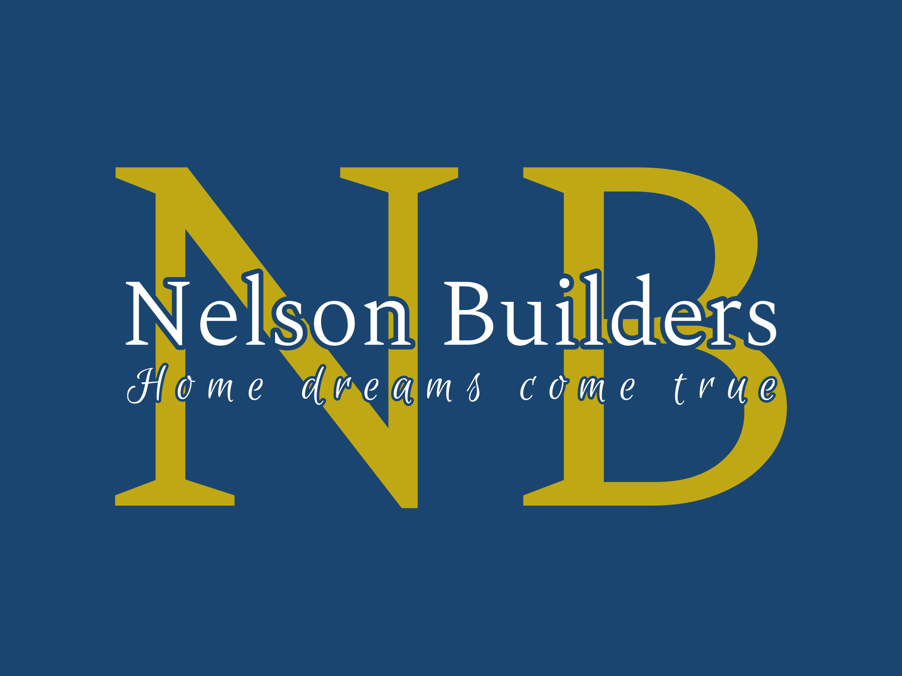

Fiberglass Pool Options
720-266-9689
nelsonbuilders.net
RG-291104142
SJC Residential Pool: BL-6487

Low Maintenance
Why are fiberglass pools so easy to maintain? It all has to do with surface porosity.
The surface of a fiberglass pool, called the gelcoat, is virtually non-porous. In contrast, the surface of a concrete pool is extremely rough and porous.
These rough cavities and pores give algae a place to hide and call home, making pool ownership much more difficult.
Concrete pool builders teach their clients that weekly brushing of the entire pool surface is mandatory to keep algae at bay.
In addition, chemical usage in concrete pools is much higher because of the need to penetrate the pool surface to kill algae.
Concrete pools also require daily doses of muriatic acid to lower the pH of the water. This is because concrete is alkaline based and constantly increases the pH of pool water. Fiberglass pools, on the other hand, are inert and do not effect water chemistry in any way.
For these reasons, fiberglass swimming pool owners typically spend 75% less time and money maintaining their pools. This means anyone who owns a fiberglass pool will spend more time in the pool and less time maintaining it.

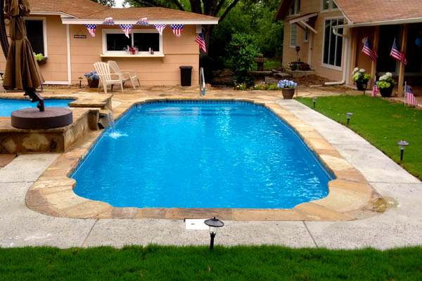

Speed of Installation
Because the fiberglass pool shell is manufactured off site, the installation of the shell typically occurs in about two to five days.
Compare this with three to six months with a concrete pool, and we're talking about a huge difference in the duration of time your yard is in disarray...and often the difference between swimming this year or waiting until next summer.
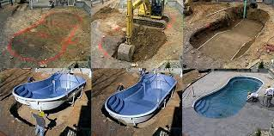

Durability
Because fiberglass swimming pools have no liner, there's no need to concern yourself with puncturing the pool surface.
Vinyl liners are not cheap...often upwards of $4–5k to replace. This can happen from dogs getting in the pool, tree branches, patio furniture blown into the pool, etc.
Fiberglass pools are incredibly strong and durable, so there's no need to be concerned about damaging the pool during daily use.
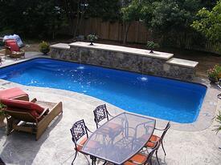

Attractive Look
Over the past 30 years, fiberglass inground pools have transformed from the typical white bathtub you'd find at a rental beach house, to the elegant swimming pool designs and aesthetic features that are now as much works of art as the pool.
This is due to advancements in the industry such as beautiful colored finishes, ceramic tile, tanning ledges, water features, stunning pool lights, elevated spas, poolside walls, etc.
This is one of the many reasons why fiberglass pools have gained exponential market share over the past decade.
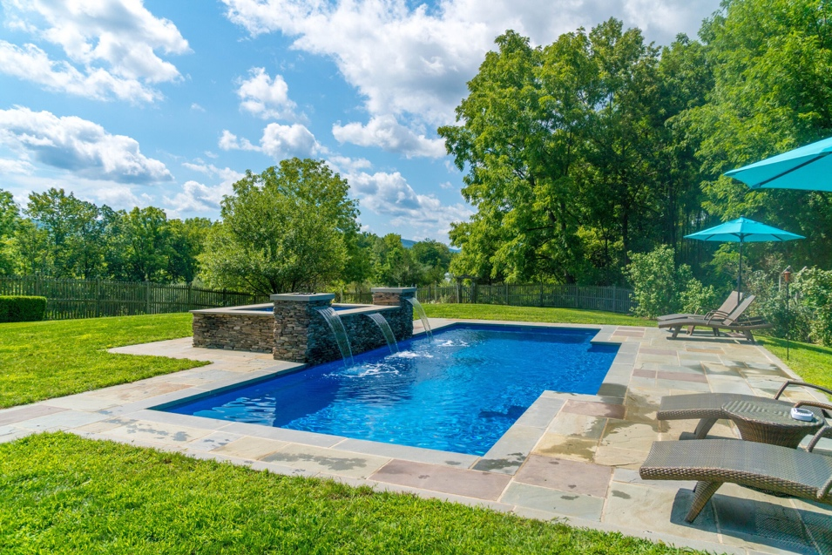

Compatibility with Salt Systems
Salt chlorinators have proven to be a low maintenance, high water quality option for pool owners.
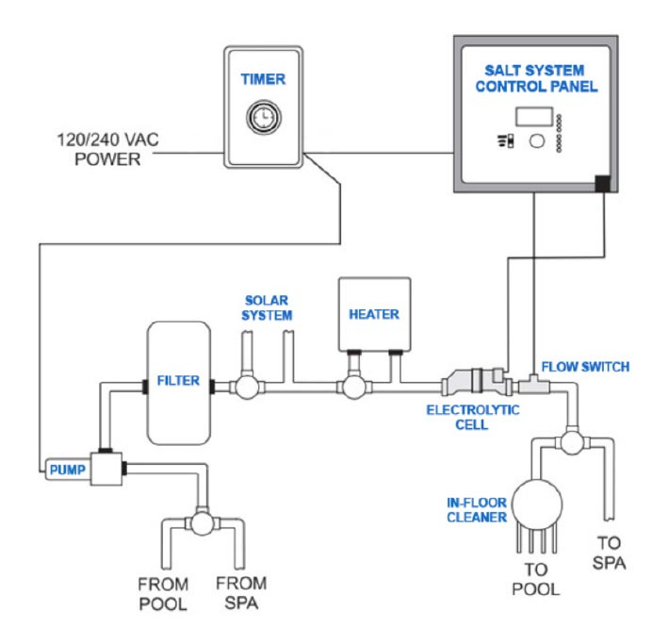

However, if you have ever seen what de-icing salt does to the surface of a sidewalk, you can guess what it does to the surface of a concrete pool. In our opinion, this makes the combination of salt systems and concrete pools unfavorable.
Also, many vinyl liner pools are constructed with metal wall panels, and most have aluminum coping around the perimeter of the pool. This is also a terrible scenario for a salt system. The liner will eventually leak, meaning good-bye wall panel!
In comparison, fiberglass pools and salt systems go together like peanut butter and jelly. With no adverse effect on the fiberglass shell, you can enjoy the low-maintenance benefits of salt with confidence that your pool is not compromised.
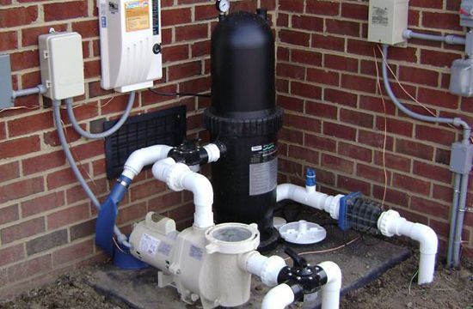

Resale Value
If a pool comes with the property, home buyers want something that looks good, needs little maintenance, and will last a long time.
Vinyl liner pools need a new liner every 5–9 years, and often a buyer will require the current owners to replace that themselves.
Vinyl liner and aboveground pools don't look great, either, and can detract value.

Home Values and Fiberglass Pools
Considering all these factors, in general, fiberglass pools do add value to a home. The National Association of Realtors has said that a concrete or fiberglass pool may add roughly 5% to a home’s value, but again, this number can vary.
In other words, although you will get some returns (financially speaking) for your swimming pool, they likely won’t match the overall cost of the pool project.
For example, let’s assume for a second that you spend $65,000 on your inground fiberglass swimming pool. The likely return on investment will be in the neighborhood of 20-30k in most cases.
Looking beyond sheer dollars though, fiberglass pools often increase the sell-ability of a home, especially when the buyers consist of children.
All this being said though, very few people and families buy a fiberglass pool because it's a financial investment. Yes, some returns are there, but the true "returns" come in the form of laughter, memories, and years of enjoyment.
Although it won't recoup the original cost of the pool itself, it does help...and the greatest value is the joy that the pool brings you and your family.

Low Lifetime Cost of Ownership
Check out the following chart to compare what the average pool owner would spend over a 10-year period with each type of pool:

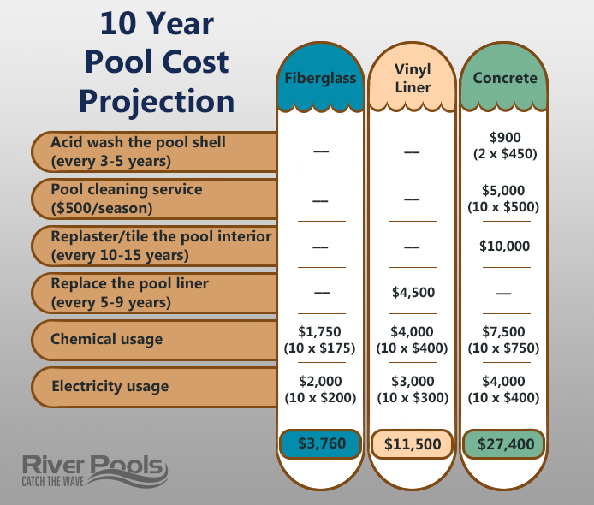

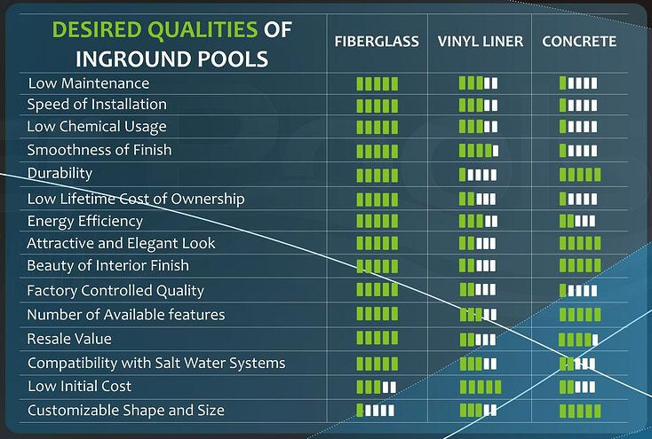

Slim Swim
with Bench

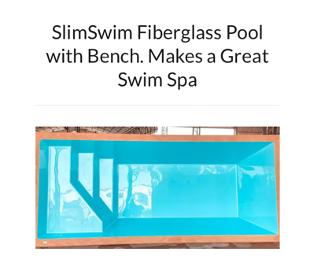

Size Options
SlimSwim 330 - 6.6ft x 10.9ft x 4.1ft
SlimSwim 400 - 6.6ft x 13.1ft x 4.7ft
SlimSwim 500 - 7.2ft x 16.4ft x 4.7ft
SlimSwim 600 - 8.2ft x 19.7ft x 4.7ft
SlimSwim 700 - 8.8ft x 23.0ft x 4.7ft
Upgrade: Add a Badu Swim System
Great as a therapy pool!

Escondido Pool with Bench

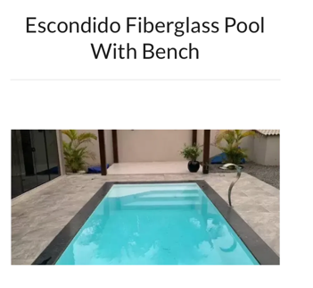

Size Options
Escondido 500 - 8.5ft x 16.4ft x 4.7ft
Escondido 600 - 9.8ft x 19.6ft x 4.7ft
Escondido KS 700 - 10.5ft x 23.0ft x 4.7ft
Escondido- KS 800 - 11.5ft x 26.3ft x 4.7ft
Great as a therapy pool!

Pro Sun with Tanning Ledge
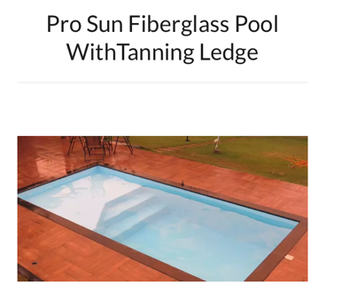

Size Options
Pro Sun 600 - 9.9ft x 19.7ft x 4.7ft
Pro Sun 700 - 10.5ft x 23.0ft x 4.7ft
Pro Sun 800 - 11.5ft x 26.3ft x 4.7ft
Upgrade: Add a Badu Swim System
Great as a therapy pool!

Freeform Tuscany

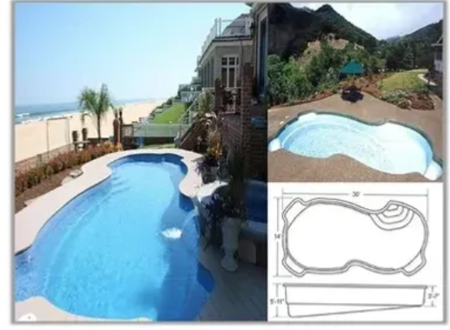

Measurements: 14’ x 30’
3’ 7” shallow end depth
5’ 11” deep end depth
Color options: white, light blue, dark blue speckle
Upgrade: Stadium Steps

Lazy L Syracusa

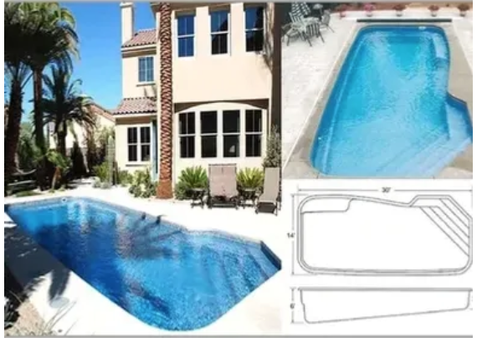

Measurements: 14’ x 30’
6’ deep end depth
3’6” shallow end depth
Color options: white, light blue, dark blue speckle

Napoli Grande

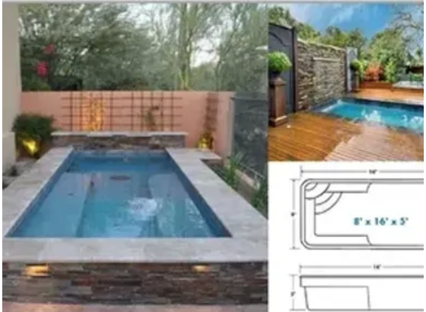

Measurements: 8’x16’
Depth throughout: 3’
Color options: white, light blue, dark blue speckle
Upgrade: Add a Badu Swim System

Moderna Rectangle

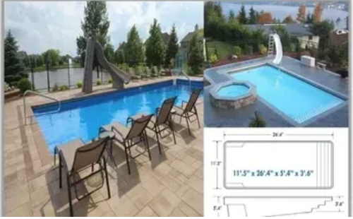

Measurements: 11’5” x 26’4”
5’4” deep end depth
3’6” shallow end depth
Color Options: white, light blue, dark blue speckle

Napoli Plunge Pool or Spa

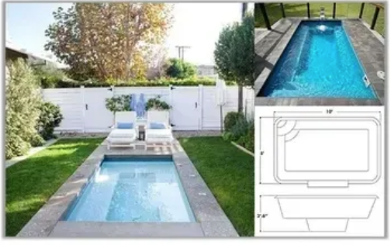

Measurements: 8’x10’
3’ 6” depth
Color Options: white, light blue, dark blue speckle
Great as a therapy pool!

Freeform Costa Rica

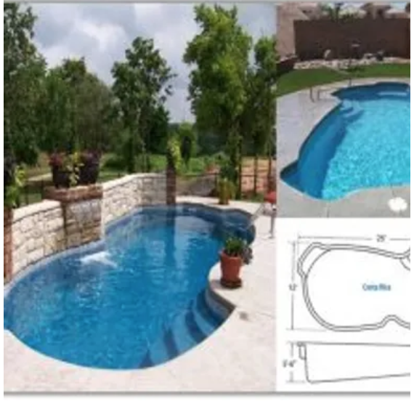

Measurements: 12’x25’
4’ deep end depth
Color Options: white, light blue, dark blue speckle

Pro Tan
With Steps and Tanning ledge

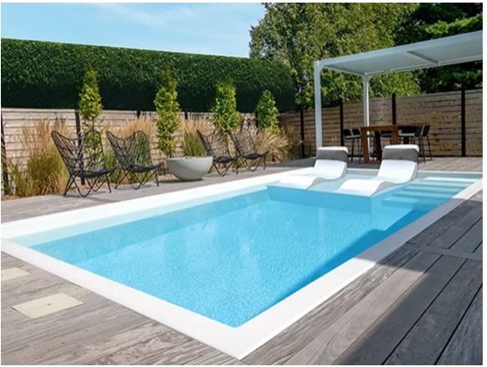

Measurements: 12’x 24”
4’ 7” Depth
Color: white

Large Deep End Pools

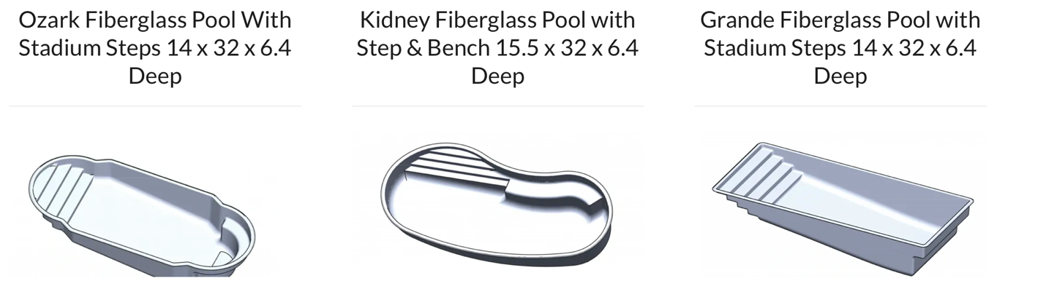

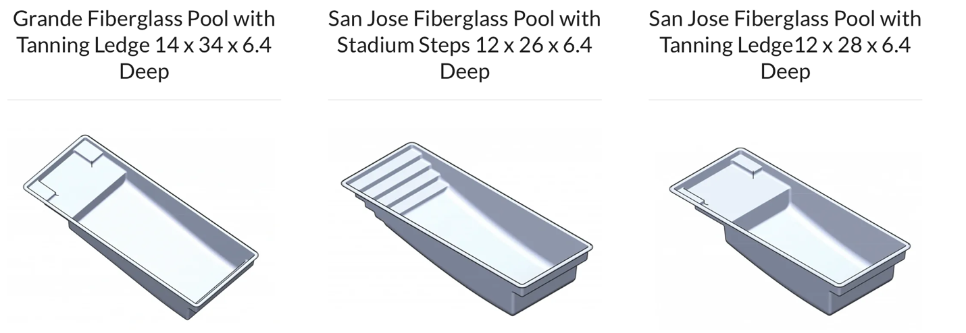

Color Options
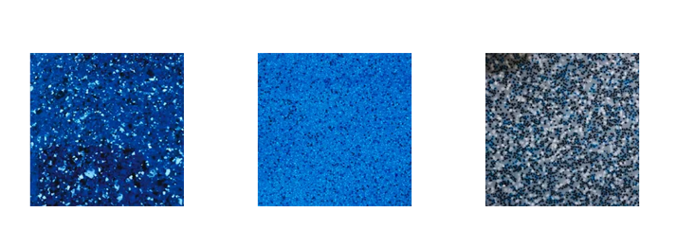

Dark blue speckle Ocean blue Blue grey

Additional Upgrade Options

Florence Tanning Ledge
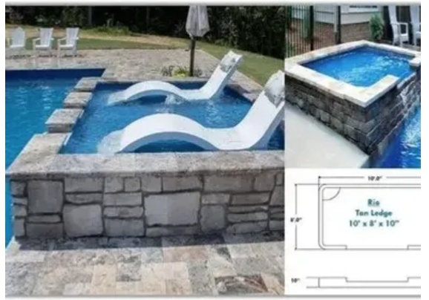
Measurements 8’x10’
10” depth

Hot Tub Option
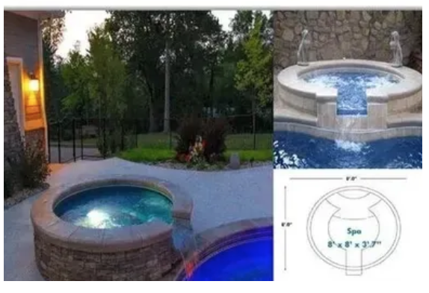
Measurements: 8’x8’
3’7” depth
Colors: white and light blue

Swim Spa

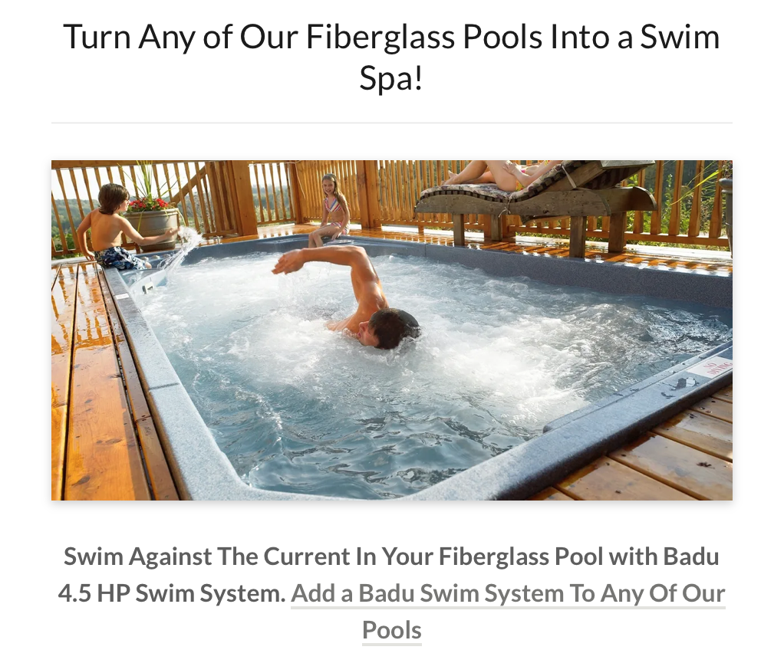

Therapy Pools

Turn any of our small to medium shells into a swim spa and therapy pool! Exercise, rehab & recovery or just sit back and relax.

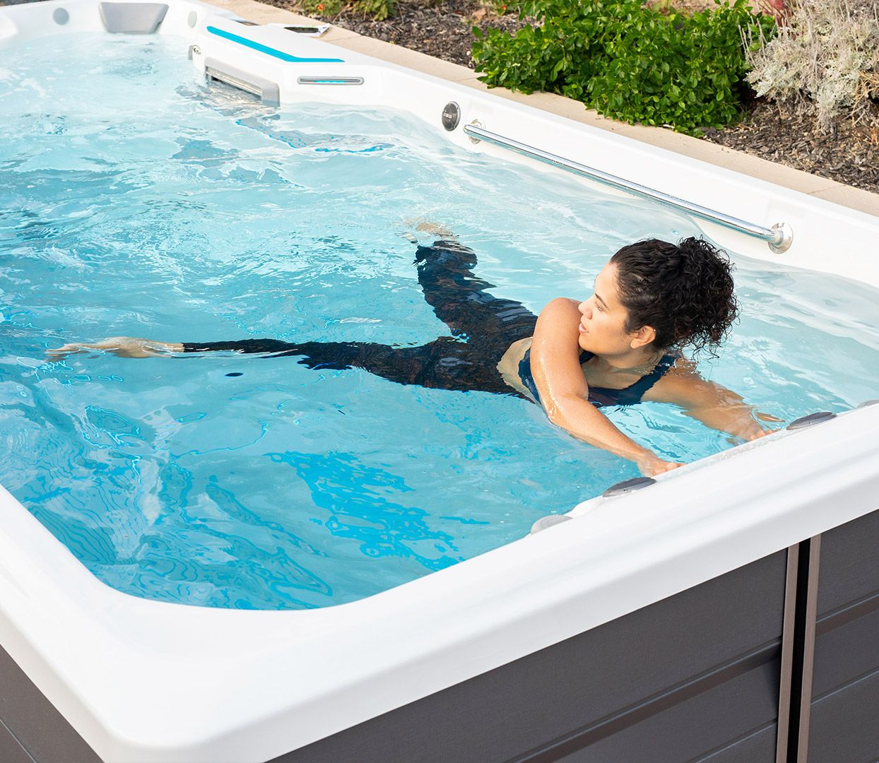

Equipment



Jandy authorized installers with variable speed pumps and filters

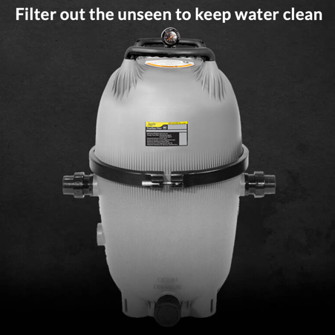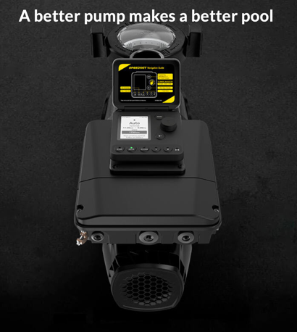

Water Sanitizers
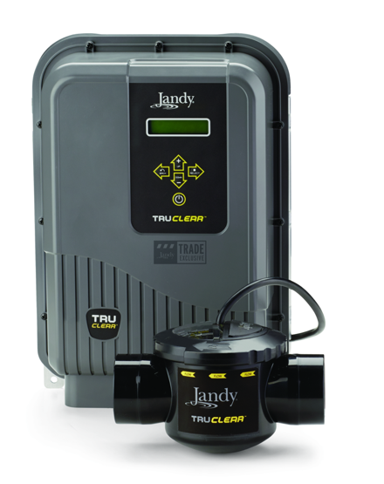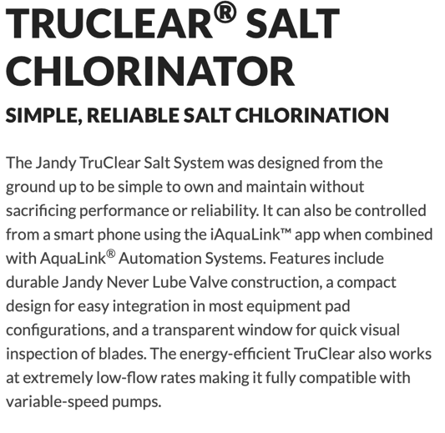
Automation

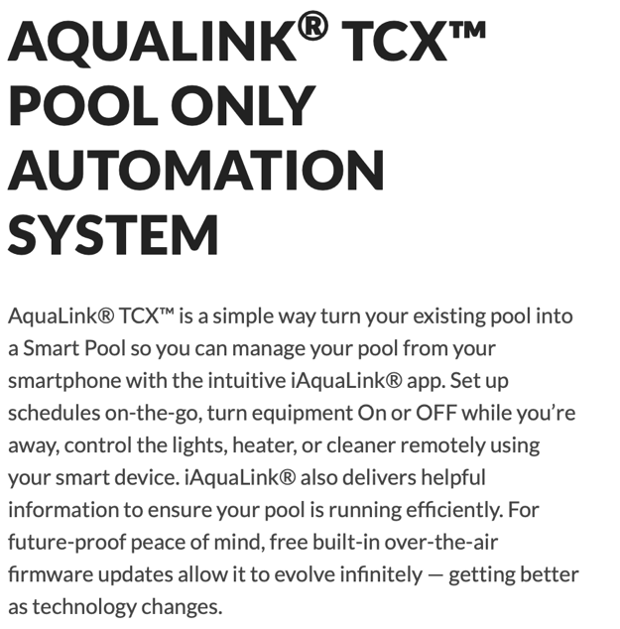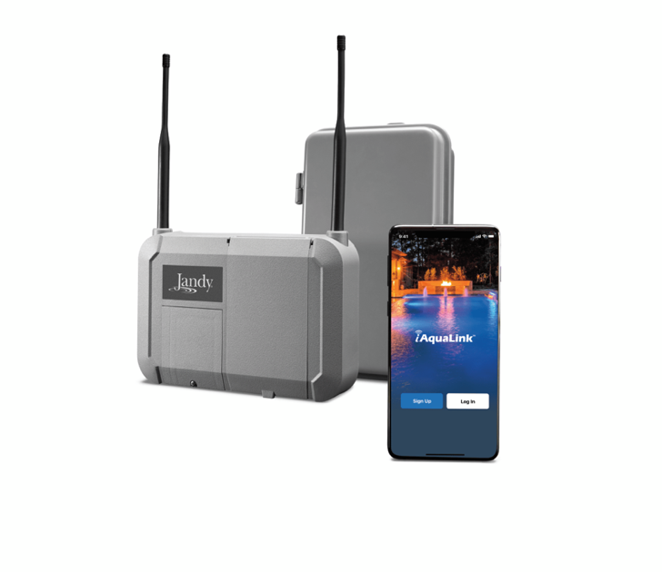

Jandy Nicheless Lights

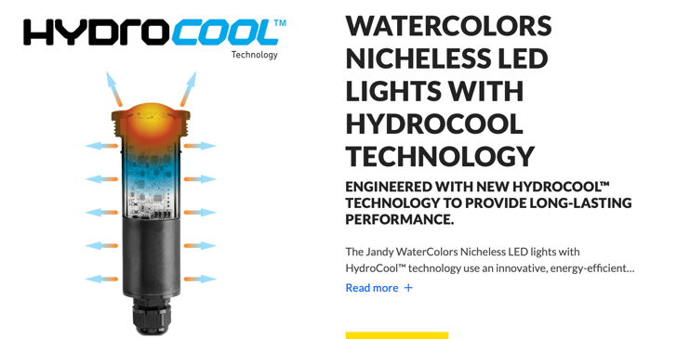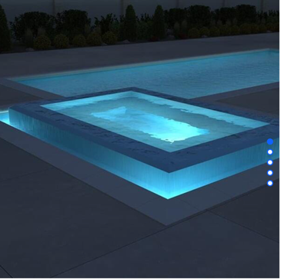

Heaters


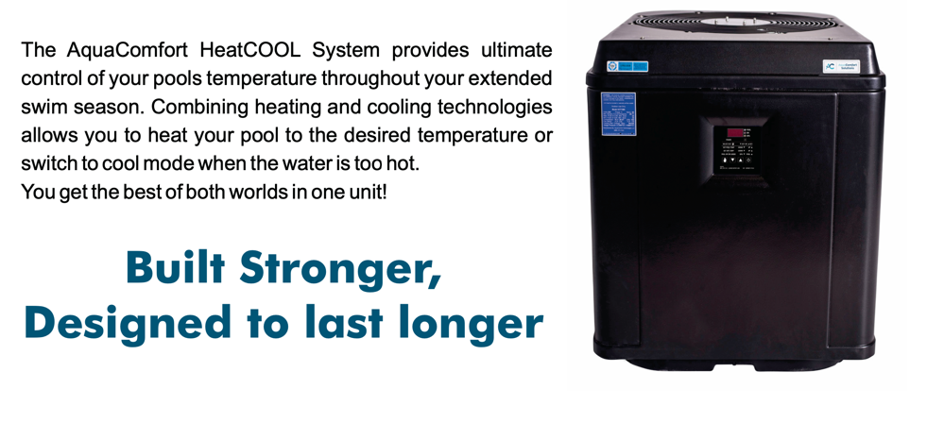

Pool and Spa Covers
by Cover Pools

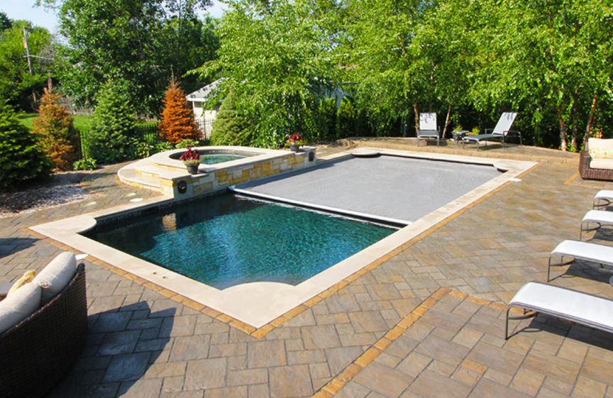

Keep Your Family Safe
Water Conservation
Return on Investment by reducing operating costs
Convenience: Keep it clean
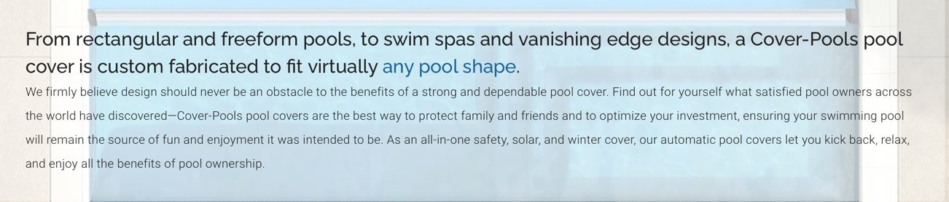

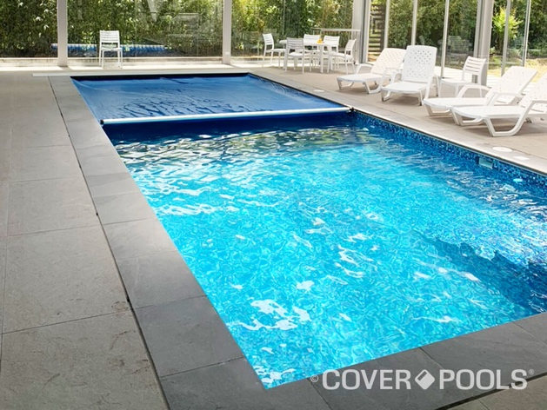

Pavers:

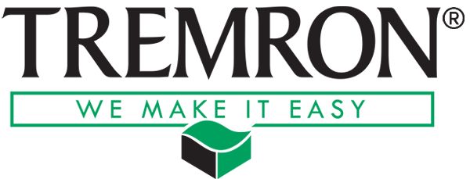

Tremron Pavers
Dozens of color options available

https://www.tremron.com/products#pavers

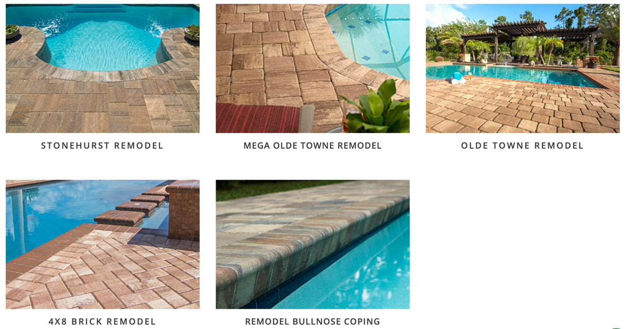

Financing Options
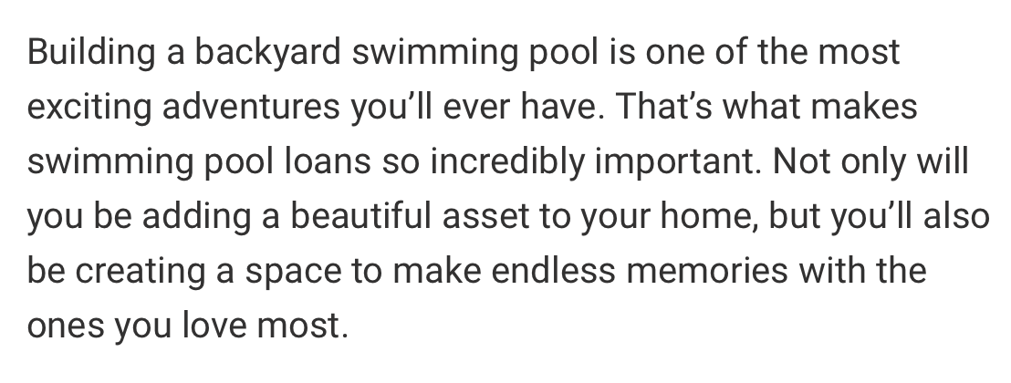


https://www.hfsfinancial.net



www.lightstream.com



https://www.lyonfinancial.net



https://poolloan.net

Why choose Nelson Builders Pools & Spas for your pool?

- We offer state of the art, modern amenities and features that other local pool builders do not. This includes automation, custom covers, variable speed pumps and lighting/water features.

- As a small, family owned company, we pride ourselves on providing superior customer service. This means you will always be able to reach someone in a timely manner. Your project, regardless of budget, will be managed from start to finish with the care and professionalism you deserve.

- We work with industry leading wholesalers and suppliers to ensure you are getting the absolute best quality product at the lowest possible price.

Nelson Builders Pools and Spas there are different phases of an actual complete installation but in general here is the list:
- Permit application
- Permit Approval
- Excavation
- Setting, Plumbing, Water Filling, and Backfilling of Pool
- Electrical Hook Up
- Forming for Coping Concrete or Pavers
- Pouring Concrete or Pavers
- Removing Concrete Forms/Patching/Etc.
- Cleaning of Pool
- Grading of Yard and Soil/Turf Installation
- Final Cleaning of Pool
- Cover Installation if Necessary
Another huge factor that one must account for is weather. One good day of rain can literally delay a job for 2 weeks, especially if the site is a difficult one and does not drain well. This goes for all inground pool types (albeit some more than others): the best time to build a pool is when it’s sunny, dry and the weather is on your side. Keep in mind the potential delays with equipment as well as an extreme demand in the industry can lead to further delays.

At Nelson Builders Pools and Spas, we tell our customers they can expect most jobs to fall in the 4–6 week range (not including permitting or obtaining the pool shell) when one actually considers all that is involved as well as potential variables that can arise.

